**Pyber Observations and Analysis**

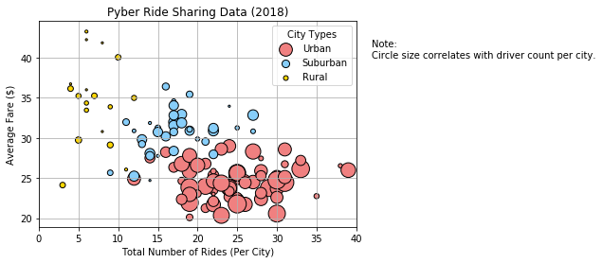**Pyber Ride Sharing Data**

**Trends Observed:**

1. Urban cities have the most drivers, exceeding both suburban and rural segments. The average trip fare for urban is < $30 and mostly in the $20-$25 range. The number of rides is more than both suburban and rural segments.
2. Suburban cities have lesser drivers than urban cities. The average trip fare is in the $30 to $ 35 range, higher than the urban rides.
3. Rural cities have the least number of drivers. The average trip fare is the highest, mostly around the $35 range. With few above $40.
4. Urban cities on an average have 15 to 35 rides where there are many drivers compared to rural and Suburban cities.
5. It is observable that urban centers have more trips but lower trip fares, could be due to lesser distance travelled but this information is not deducible from the data provided.

**Pie Chart for Percentage of Total Fares by City Type**

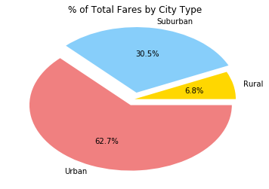

**Pie Chart for Total Rides by City Type**

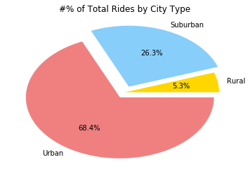

**Pie Chart for Total Drivers by City Type**

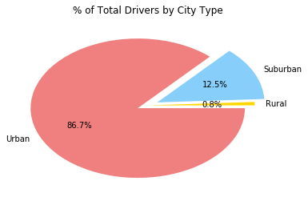

**Trends Observed:**

1. Urban centers contribute to bulk of the fares, revenue. And these centers have the most drivers and most number of rides.
2. Slightly less than 70% of rides are in Urban Cities, little more than 26% of rides are in Suburban cities. Rural cities have slightly more than roughly 5% (round off) rides.
3. The fares of Suburban cities generate 30% or revenue, Urban cities generate 63% of revenue and rural cities generate slightly less than 7% revenue.
4. As inferred from the scatter plot it is also noticeable from the pie charts that the urban centers have more trips but lower trip fares, could be due to lesser distance travelled but this information is not deducible from the data provided.